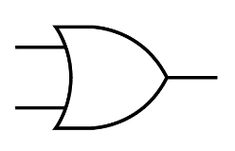**Circuit Diagram & Truth Table:**

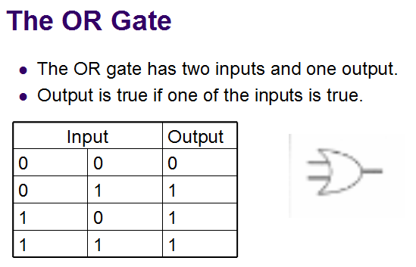

**Code:**

* **Design Module**

module gate(z,x,y);

input x,y;

output z;

assign z=x|y;

endmodule

* **TestBench**

module Baig;

reg x,y;

wire z;

gate g1(z,x,y);

initial

begin

x=1'b0;y=1'b0;

#20

x=1'b0;y=1'b1;

#20

x=1'b1;y=1'b0;

#20

x=1'b1;y=1'b1;

#20

$finish;

end

endmodule

**Output:**

